SIMATS ENGINEERING

ASSESSMENT TOOL 1 – SCENARIO BASED ASSIGNMENT

Question 1 – Greedy Best-First Search
Map data used: road distances g (Gate–Library 120, Gate–Canteen 200, Library–Lab 150, Library–Hostel 300, Canteen–Hostel 100, Canteen–Admin 260, Lab–Auditorium 350, Hostel–Auditorium 180, Admin–Auditorium 120) and straight-line distance h to the Auditorium (Gate 400, Library 330, Canteen 240, Lab 280, Hostel 160, Admin 110, Auditorium 0).

a) Search strategy
The robot uses Greedy Best-First Search, an informed (heuristic) search.
- It always expands the neighbour with the lowest heuristic value h(n) – the straight-line distance to the goal – so the evaluation is f(n) = h(n).
- It ignores g(n), the distance already travelled. This is exactly what the scenario describes (“does not consider how far it has already travelled”), which is the defining property of greedy search.

b) Trace of decisions
Step | Location expanded | Candidates (unvisited neighbours) with straight-line h | Decision
1 | Gate | Library = 330, Canteen = 240 | Canteen (240 < 330)
2 | Canteen | Hostel = 160, Admin = 110 (Gate already visited) | Admin (110 < 160)
3 | Admin | Auditorium = 0 | Auditorium (goal reached)

c) Route, distance and optimality
Route: Gate → Canteen → Admin → Auditorium Distance = 200 + 260 + 120 = 580 m
Not guaranteed to be shortest. Greedy search is neither optimal nor complete in general because it looks only at the estimate, never at the cost already paid. Comparison of all routes:
Route | Total distance (m) | Remark
Gate → Canteen → Hostel → Auditorium (200+100+180) | 480 | Shortest
Gate → Canteen → Admin → Auditorium (200+260+120) | 580 | Greedy route
Gate → Library → Hostel → Auditorium (120+300+180) | 600
Gate → Library → Lab → Auditorium (120+150+350) | 620
The greedy route is 100 m (about 21%) longer than the best route. The mistake happens at the Canteen: Admin looks closer (110 vs 160) but the road to it costs 260 m, whereas Hostel is only 100 m away. Greedy search cannot see this cost.
Program 1 (q1_greedy.py)
# Question 1 - Greedy Best-First Search (campus delivery robot)
roads = {
"Gate": {"Library": 120, "Canteen": 200},
"Library": {"Gate": 120, "Lab": 150, "Hostel": 300},
"Canteen": {"Gate": 200, "Hostel": 100, "Admin": 260},
"Lab": {"Library": 150, "Auditorium": 350},
"Hostel": {"Library": 300, "Canteen": 100, "Auditorium": 180},
"Admin": {"Canteen": 260, "Auditorium": 120},
"Auditorium": {"Lab": 350, "Hostel": 180, "Admin": 120},
}
h = {"Gate": 400, "Library": 330, "Canteen": 240, "Lab": 280,
"Hostel": 160, "Admin": 110, "Auditorium": 0}

def greedy(start, goal):
current, visited, path, total = start, {start}, [start], 0
step = 1
while current != goal:
cands = {n: h[n] for n in roads[current] if n not in visited}
print(f"Step {step}: expand {current:<10} candidates (h) = {cands}")
nxt = min(cands, key=cands.get)
total += roads[current][nxt]
visited.add(nxt); path.append(nxt); current = nxt; step += 1
return path, total

if __name__ == "__main__":
path, dist = greedy("Gate", "Auditorium")
print("Route:", " -> ".join(path), "| Distance:", dist, "m")

Output :
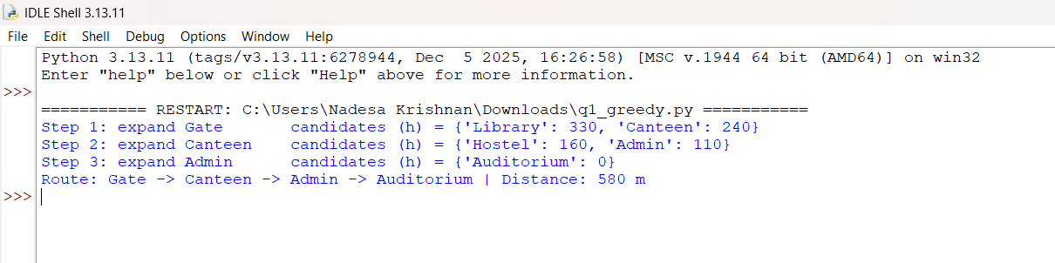

Question 2 – A* Search

a) New strategy
The new rule f(n) = g(n) + h(n) is A* search.
- g(n) is the exact cost from the Gate to n; h(n) is the straight-line estimate from n to the Auditorium, so f(n) estimates the total cost of the best route passing through n.
- A* always expands the open node with the lowest f. It is guaranteed to return the shortest route provided h is admissible (never over-estimates the true remaining distance); with a consistent h it never needs to re-expand a node. A straight line can never be longer than a road, so this holds here (checked in part c).

b) Trace of the new rule
Step | Expanded | Candidate | g | h | f = g+h | Decision / open list
1 | Gate (f=400) | Library | 120 | 330 | 450 | Open: Library 450, Canteen 440  Pick Canteen (lowest f)
 |  | Canteen | 200 | 240 | 440
2 | Canteen (f=440) | Hostel | 300 | 160 | 460 | Open: Library 450, Hostel 460, Admin 570  Pick Library
 |  | Admin | 460 | 110 | 570
3 | Library (f=450) | Lab | 270 | 280 | 550 | Hostel via Library: g=420, f=580 – worse than 460, discarded  Open: Hostel 460, Lab 550, Admin 570  Pick Hostel
4 | Hostel (f=460) | Auditorium | 480 | 0 | 480 | Open: Auditorium 480, Lab 550, Admin 570  Pick Auditorium
5 | Auditorium (f=480) | – | 480 | 0 | 480 | Goal removed from open list with lowest f → stop
Route: Gate → Canteen → Hostel → Auditorium, distance = 200 + 100 + 180 = 480 m.

c) Comparison with Question 1
Location | Straight-line h | True remaining distance h* | h ≤ h* ?
Gate | 400 | 480 (200+100+180) | Yes
Library | 330 | 480 (300+180) | Yes
Canteen | 240 | 280 (100+180) | Yes
Lab | 280 | 350 | Yes
Hostel | 160 | 180 | Yes
Admin | 110 | 120 | Yes
Every straight-line value is less than or equal to the true remaining road distance, so the heuristic is admissible and A* is guaranteed to give the shortest route. It is also consistent: h(n) ≤ cost(n, n') + h(n') for every road (for example Canteen→Hostel: 240 ≤ 100 + 160).
 | Q1 – Greedy | Q2 – A*
Route | Gate → Canteen → Admin → Auditorium | Gate → Canteen → Hostel → Auditorium
Distance | 580 m | 480 m
Nodes expanded | 3 (Gate, Canteen, Admin) | 4 (Gate, Canteen, Library, Hostel)
Optimal? | No | Yes
A* gives a route that is 100 m shorter (about 17% saving). It does a little more searching (one extra expansion) but guarantees the best answer, which is the trade-off the administration wanted.
Program 2 (q2_astar.py)
# Question 2 - A* Search: f(n) = g(n) + h(n)
import heapq
from q1_greedy import roads, h # reuse the campus map from Q1

def a_star(start, goal):
open_list = [(h[start], 0, start, [start])]
best_g = {start: 0}
step = 1
while open_list:
f, g, node, path = heapq.heappop(open_list)
if g > best_g.get(node, float("inf")):
continue
print(f"Step {step}: expand {node:<10} g={g:<4} h={h[node]:<4} f={f}")
step += 1
if node == goal:
return path, g
for nb, w in roads[node].items():
ng = g + w
if ng < best_g.get(nb, float("inf")):
best_g[nb] = ng
print(f" generate {nb:<10} g={ng:<4} h={h[nb]:<4} f={ng + h[nb]}")
heapq.heappush(open_list, (ng + h[nb], ng, nb, path + [nb]))
return None, float("inf")

path, dist = a_star("Gate", "Auditorium")
print("Route:", " -> ".join(path), "| Distance:", dist, "m")

# Admissibility check: true remaining distance (Dijkstra) vs straight-line h
def true_dist(src, goal="Auditorium"):
pq, seen = [(0, src)], {}
while pq:
d, n = heapq.heappop(pq)
if n in seen: continue
seen[n] = d
for nb, w in roads[n].items():
heapq.heappush(pq, (d + w, nb))
return seen[goal]

print("\nLocation h(n) true h<=true")
for n in roads:
t = true_dist(n)
print(f"{n:<10} {h[n]:<5} {t:<5} {h[n] <= t}")

Output :
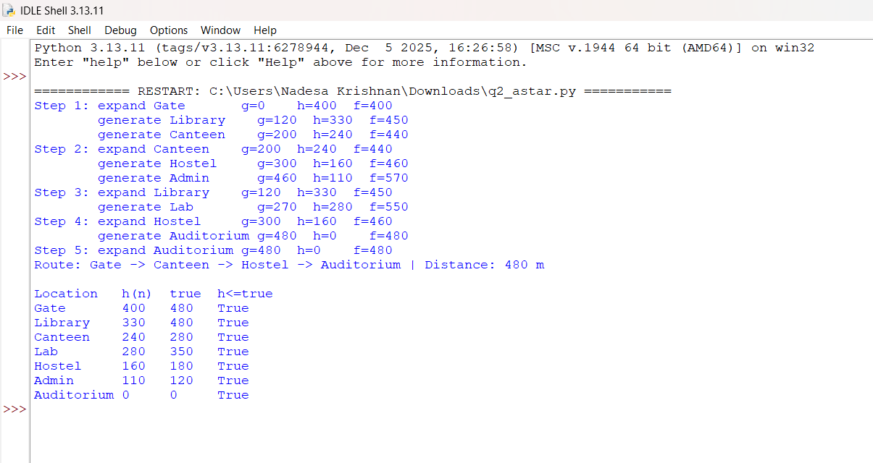

Question 3 – Constraint Satisfaction Problem

a) Problem type and formulation
This is a Constraint Satisfaction Problem (CSP) – a scheduling problem equivalent to graph colouring (workshops = nodes, shared students = edges, time slots = colours).
- Variables: W1, W2, W3, W4, W5 (the slot of each workshop).
- Domains: {Morning, Afternoon, Evening} for each; after applying the unary constraints: D(W3) = {Afternoon, Evening}, D(W4) = {Morning, Afternoon}, D(W1) = D(W2) = D(W5) = all three.
- Binary constraints (different slots): W1≠W2, W1≠W3, W2≠W3, W2≠W4, W3≠W5, W4≠W5.
- Unary constraints: W3 ≠ Morning (trainer); W4 ≠ Evening (hall).

b) Building the timetable
Method: pick the variable with the fewest remaining slots (MRV); break ties by the most unscheduled conflicting workshops (degree), then by lower workshop number; try slots in the order Morning, Afternoon, Evening; after each assignment remove that slot from the unscheduled neighbours (forward checking).
Initial domains: W1 {M,A,E}, W2 {M,A,E}, W3 {A,E}, W4 {M,A}, W5 {M,A,E} (M = Morning, A = Afternoon, E = Evening)
Step | Workshop chosen and why | Assignment | Remaining slots of unscheduled workshops
1 | W3 and W4 both have 2 slots; W3 has 3 unscheduled conflicts (W1, W2, W5) vs 2 for W4 → W3 | W3 = Afternoon | W1 {M,E}, W2 {M,E}, W4 {M,A}, W5 {M,E}
2 | All have 2 slots; unscheduled conflicts: W1=1, W2=2, W4=2, W5=1; tie W2/W4 → lower number W2 | W2 = Morning | W1 {E}, W4 {A}, W5 {M,E}
3 | W1 and W4 have 1 slot; unscheduled conflicts: W1=0, W4=1 → W4 | W4 = Afternoon | W1 {E}, W5 {M,E}
4 | W1 has 1 slot (fewest) | W1 = Evening | W5 {M,E}
5 | Only W5 left; Morning tried first | W5 = Morning | –
Final valid timetable:
Slot | Workshops | Check
Morning | W2, W5 | W2 and W5 share no students ✔
Afternoon | W3, W4 | W3 and W4 share no students; W3 not in Morning ✔
Evening | W1 | W4 not in Evening ✔
All six conflict pairs are in different slots (W1–W2: E/M, W1–W3: E/A, W2–W3: M/A, W2–W4: M/A, W3–W5: A/M, W4–W5: A/M) and both availability constraints hold.

c) Why MRV helps and what to do on a dead end ?
- Why fewest-slots-first helps: a variable with few legal values is the most likely to fail later. Scheduling it first (“fail-first”) exposes dead ends early, near the root of the search tree, so large wrong subtrees are pruned instead of explored. Forward checking then shrinks the other domains immediately, and the degree tie-break picks the variable that constrains the most others.
- If a workshop ends with no slot: the current partial assignment cannot be completed, so backtrack – undo the latest assignment (restoring the removed slots), try the next slot for that workshop, and go further back if it also fails. If every option fails, the problem is unsolvable as stated and a constraint must be relaxed (e.g. add a fourth slot or free the trainer/hall).

Program 3 (q3_csp.py)
# Question 3 - CSP: workshop timetable with MRV + degree tie-break + forward checking
SLOTS = ["Morning", "Afternoon", "Evening"]
conflicts = [("W1","W2"),("W1","W3"),("W2","W3"),("W2","W4"),("W3","W5"),("W4","W5")]
domains = {f"W{i}": list(SLOTS) for i in range(1, 6)}
domains["W3"].remove("Morning") # W3 trainer unavailable in the morning
domains["W4"].remove("Evening") # W4 hall unavailable in the evening
neigh = {w: set() for w in domains}
for a, b in conflicts:
neigh[a].add(b); neigh[b].add(a)

def pick(domains, assigned):
un = [w for w in domains if w not in assigned]
# fewest remaining slots -> most unscheduled conflicts -> lowest number
return min(un, key=lambda w: (len(domains[w]),
-len([n for n in neigh[w] if n not in assigned]), int(w[1:])))

def solve(domains, assigned):
if len(assigned) == len(domains):
return assigned
w = pick(domains, assigned)
for slot in domains[w]: # Morning, Afternoon, Evening
new = {k: list(v) for k, v in domains.items()}
new[w] = [slot]
ok = True
for n in neigh[w]:
if n not in assigned:
if slot in new[n]: new[n].remove(slot)
if not new[n]: ok = False # dead end -> backtrack
if ok:
a2 = dict(assigned); a2[w] = slot
rem = {k: v for k, v in new.items() if k not in a2}
print(f"Assign {w} = {slot:<9} remaining domains: {rem}")
res = solve(new, a2)
if res: return res
return None

print("Initial domains:", domains)
sol = solve(domains, {})
print("\nTimetable:")
for w in sorted(sol): print(f" {w}: {sol[w]}")
assert all(sol[a] != sol[b] for a, b in conflicts)
assert sol["W3"] != "Morning" and sol["W4"] != "Evening"
print("All constraints satisfied.")

Output :

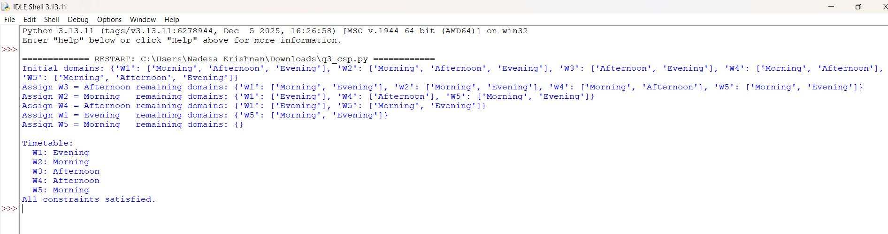

Question 4 – Minimax

a) Technique and assumption
The bot should use the Minimax algorithm (two-player, zero-sum, perfect information). X is the MAX player and O is the MIN player. The assumption is that Player O plays optimally (rationally) and always picks the reply that minimises X’s score, so X chooses the move whose worst-case outcome is best.

b) Values of all nodes
Tree: Root (X moves, MAX) → two first moves A, B → O replies (MIN) → X’s final moves (MAX) → leaf scores.
Level / node | Type | Children values | Node value
After A, reply 1 (leaves 4, 7) | MAX (X) | 4, 7 | 7
After A, reply 2 (leaves 8, 2) | MAX (X) | 8, 2 | 8
After B, reply 1 (leaves 3, 5) | MAX (X) | 3, 5 | 5
After B, reply 2 (leaves 6, 9) | MAX (X) | 6, 9 | 9
Move A (O to reply) | MIN (O) | 7, 8 | 7
Move B (O to reply) | MIN (O) | 5, 9 | 5
Root – starting position | MAX (X) | 7, 5 | 7

c) Best move, guaranteed score and play
- Best first move: the left move (A), since 7 > 5.
- Guaranteed score: 7 – X can secure at least 7 whatever O does.
- Best play: X plays the left first move → O replies with the left reply (leaving X a maximum of 7, rather than 8 after the right reply) → X plays its second (right) final move, scoring 7. Choosing the right first move would let O hold X to 5, so it is worse.

Program 4 (q4_minimax.py)
# Question 4 - Minimax on a Max-Min-Max tree
tree = [ # X move -> O reply -> X final-move scores
[[4, 7], [8, 2]], # first move A (left)
[[3, 5], [6, 9]], # first move B (right)
]
def minimax(node, is_max, label):
if isinstance(node, int):
return node
vals = [minimax(c, not is_max, f"{label}{i+1}") for i, c in enumerate(node)]
v = max(vals) if is_max else min(vals)
print(f"{'MAX' if is_max else 'MIN'} node {label or 'root':<5} children={vals} -> {v}")
return v

best = minimax(tree, True, "")
print("Value of the game for X:", best)
Output :

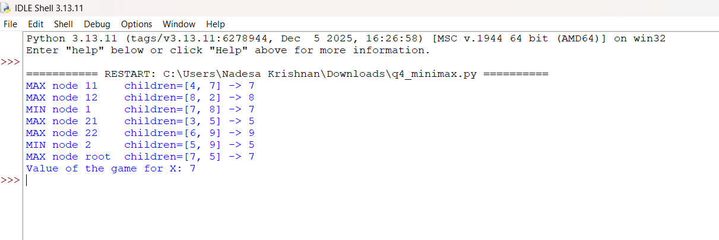

Question 5 – Alpha-Beta Pruning

a) Evaluation left to right with pruning
The engine is MAX (alpha = best value guaranteed for it so far); the opponent’s replies are MIN nodes (beta = best value for the opponent so far). A branch is cut when beta ≤ alpha.
Move | Position scored | alpha | beta | Action
M1 | 6 | −∞ | 6 | continue
M1 | 9 | −∞ | 6 | min stays 6
M1 | 7 | −∞ | 6 | M1 = 6 → alpha = 6
M2 | 4 | 6 | 4 | beta 4 ≤ alpha 6 → PRUNE; skip 8 and 10 (M2 ≤ 4)
M3 | 7 | 6 | 7 | continue
M3 | 5 | 6 | 5 | beta 5 ≤ alpha 6 → PRUNE; skip 12 (M3 ≤ 5)
Skipped positions: 8 and 10 under M2, and 12 under M3.

b) Result
- Positions actually scored: 6 of 9 (3 for M1, 1 for M2, 2 for M3).
- Move chosen: M1, with value 6.
- Check against full minimax: min(M1) = 6, min(M2) = 4, min(M3) = 5, and max(6, 4, 5) = 6 → move M1, value 6. The result is identical; pruning only removed positions that could not change the decision.

c) Move ordering and the evaluation function
- Effect of ordering: pruning is strongest when the best moves are examined first, because a high alpha is established early and more later branches are cut. With the order M2, M1, M3, 8 positions would be scored (only 12 skipped). If, in addition, the refuting reply is examined first in each opponent node (e.g. M3 as 5, 7, 12), only 5 positions are scored. In the worst ordering nothing is pruned and all 9 are scored. The final answer never changes; only the work does. With perfect ordering alpha-beta can search about twice as deep as plain minimax in the same time.
- Evaluation function is needed: the game tree is too large to search to terminal positions, so the search stops at a fixed depth. The evaluation function gives a numeric estimate of how good a non-terminal position is for the engine (using features such as material, mobility or position). Without it the engine would have no values to back up, and the quality of its play depends directly on how good this estimate is.

Program 5 (q5_alphabeta.py)
# Question 5 - Alpha-Beta pruning (Max root, Min replies)
moves = {"M1": [6, 9, 7], "M2": [4, 8, 10], "M3": [7, 5, 12]}
alpha, beta = float("-inf"), float("inf")
best_move, scored = None, 0
for m, replies in moves.items():
b = beta
val = float("inf")
for i, s in enumerate(replies):
scored += 1
val = min(val, s); b = min(b, val)
print(f"{m}: score {s} -> best so far for MIN (beta) = {b}, alpha = {alpha}")
if b <= alpha:
skipped = replies[i+1:]
print(f" PRUNE {m}: beta {b} <= alpha {alpha}; skipped {skipped}")
break
if val > alpha:
alpha, best_move = val, m
print(f" {m} value = {val if val>=alpha else '<= ' + str(val)} | alpha = {alpha}")
print(f"\nPositions scored: {scored} of 9 | Best move: {best_move} | Value: {alpha}")
full = max(min(r) for r in moves.values())
print("Full minimax value:", full, "-> same result:", full == alpha)

Output :

